**VISVESVARAYA TECHNOLOGICAL UNIVERSITY**



MINI PROJECT REPORT ON

**“FM TRANSMITTER”**

SUBMITTED BY:

**THOTA VENKATA ROHITH-1NH18EC113**

**PEDDISETTY MAHIDHAR-1NH18EC085**

**UMADEVI-1NH18EC114**

**S SANDEEP-1NH18EC109**

Under the guidance of

**ISHANI MISHRA**

Dept. of ECE, NHCE, Bengaluru.

# C:\Documents and Settings\Students\Local Settings\Temporary Internet Files\Content.Word\download (1).jpg

# NEW HORIZON COLLEGE OF ENGINEERING

(ISO-9001:2000 certified, Accredited by NAAC ‘A’, Autonomous college permanently affiliated to VTU)Outer Ring Road, Panathur Post, Near Marathalli, Bengaluru-560103

## NEW HORIZON COLLEGE OF ENGINEERING

## DEPARTMENT OF ELECTRONICS AND COMMUNICATION ENGINEERING



**CERTIFICATE**

Certified that the mini project work entitled “**FM TRANSMITTER**” carried out by **T.V.ROHITH(1NH18EC113),P.MAHIDHAR(1NH18EC085),UMADEVI(1NH18EC114),S.SANDEEP(1NH18EC109)** bonafide students of Electronics and Communication Department , New Horizon College of Engineering, Bangalore.

The mini project report has been approved as it satisfies the academic requirements in respect of mini project work prescribed for the said degree.

Project Guide HOD ECE

------------------------- -------------------------

**External Viva**

Name of Examiner Signature with Date

1.

2.

**ACKNOWLEDGEMENT**

The satisfaction that accompany the successful completion of any task would be, but impossible without the mention of the people who made it possible, whose constant guidance and encouragement helped us succeed.

We thank **Dr. Mohan Manghnani**, Chairman of **New Horizon Educational Institution**, for providing necessary infrastructure and creating good environment.

We also record here the constant encouragement and facilities extended to us by **Dr.Manjunatha**, Principal, NHCE and **Dr. Sanjeev Sharma**, head of the department of Electronics and Communication Engineering. We extend sincere gratitude to them.

We sincerely acknowledge the encouragement, timely help and guidance to us by our beloved guide **ISHANI MISHRA** to complete the project within stipulated time successfully.

Finally, a note of thanks to the teaching and non-teaching staff of electronics and communication department for their co-operation extended to us, who helped us directly or indirectly in this successful completion of mini project.

T.V.ROHITH-1NH18EC113

P.MAHIDHAR-1NH18EC085

UMADEVI-1NH18EC114

S.SANDEEP-1NH18EC109

**TABLE OF CONTENTS**

ABSTRACT

**CHAPTER 1**

INTRODUCTION…………………………………………………………………………………3

**CHAPTER 2**

LITERATURE SURVEY………………………………………………………………………… 4

**CHAPTER 3**

PROPOSED METHODOLOGY…………………………………………………………………..6

**CHAPTER 4**

PROJECT DESCRIPTION ………………………………………………………………………..9

4.1 HARDWARE DESCRIPTION……………………………………………………………….11

4.2 SOFTWARE DESCRIPTION…………………………………………………………………19

**CHAPTER 5**

RESULTS AND DISCUSSION…………………………………………………………………22

**CHAPTER 6**

CONCLUSION AND FUTURE SCOPE …………………………………………………………27

REFERENCES…………………………………………………………………………………….57

APPENDIX………………………………………………………………………………………..58

**LIST OF FIGURES**

|  |  |  |
| --- | --- | --- |
| **FIGURE**  **No** | **FIGURE DESCRIPTION** | **Page**  **No** |
| 1 | Circuit diagram of fm transmitter | 3 |
| 2 | Inductor coil(0.1uH) |  |
| 3 | Transistor |  |
| 4 | Aerial antenna |  |

### LIST OF TABLES

|  |  |  |  |
| --- | --- | --- | --- |
| **SL**  **No** | **Table**  **No** | **TABLE DESCRIPTION** | **Page**  **No** |
| 1 | 1 | Components | 32 |
| 2 | 2 | Problems |  |

**ABSTRACT**

The transmission of radio signal is commonly achieved by the use of frequency modulation technique. This is a demonstration of the use of a diode and differential oscillator to produce frequency modulated signal at receiver

The diode modulator approach was adopted in the design of the voltage of the voltage controlled oscillator. While a BJT differential oscillator design. Which produces a negative resistance was used to generate the carried signal to be modulated. The circuit was able to produce a very good and better quality of sound which we will hear with in 30m radius

The FM remote receiver venture relies upon FM innovation. In this framework, we fabricated a FM modulator that regulates the information sign and afterward transmits it into the FM band by means of the framework radio wire. This info sign is the electrical heartbeat produced by Mic that goes about as a transducer that changes over the voice into an electrical impulse.The transmitted FM waves can be gotten by any standard FM radio recipient of PDAs with an incorporated FM receiver.In along these lines, we can have a remote FM mouthpiece with the assistance of this task.

The FM tuning circuit can adjust a low recurrence sign utilizing a high recurrence signal. 88 MHz to 108 MHz is the range wherein the transporter recurrence are be chosen.The adjustment circuit comprises of a curl, a couple of transistors and its inclination circuit. Utilizing this regulation circuit, the human voice from 20 Hz to 20 kHz turns into a high recurrence signal.This recurrence sign is transmitted by the recieving wire utilizing the tuning circuit.This signal, when gotten on any standard FM collector and is intensified and transmitted to enormous speakers, the beneficiary's voice can contact a wide group of spectators.

|  |  |
| --- | --- |
| FM TRANSMITTER | **2019** |

**CHAPTER 01**

**INTRODUCTION**

Over a past few years there has been a rapid growth in the utilization of RF region of the electromagnetic spectrum. This is because of huge growth in the number of mobile phone subscriptions in recent times.

Li-Fi stands for light fidelity operates in the visible light spectrum of the electro magnetic spectrum. It uses visible light as a medium of transmission rather than the traditional radio waves.

* Making a remote mouthpiece at home can be a great deal of fun. Here we learn one of those straightforward undertakings that can be utilized to record and send back your remote voice.
* Microphone units and remote intensifiers are ordinarily utilized during PA programs, organize excitement, or any of the manners in which that voice sign are enhanced to be discernible in a bigger territory and separation.
* This FM Wireless Microphone Transmitter has been a very well known undertaking for tenderfoot and experienced developers.
* It has been utilized inside guitars and as a reason for a remote control framework. Be that as it may, I get numerous solicitations for a more powerful circuit and better mouthpiece affectability. I would now be able to present the new FM remote amplifier, which additionally offers better recurrence strength, a scope of more than 1 km (in perfect conditions) and is appropriate for receiver affectability. This was finished by including a RF intensifier cushion (with a 10 dB gain) and an AF preamplifier to marginally build the adjustment

Li-Fi is transmission of data using visible light by sending data through an LED light bulb that varies in intensity faster than a human eye can follow.

A remote amplifier, or a remote receiver, is a mouthpiece without a physical link that interfaces it legitimately to the sound recording or enhancement gear with which it is related. Additionally called a radio mouthpiece, it has a little battery-fueled radio transmitter in the body of the amplifier, which transmits the sound sign from the radio receiver to a close by getting unit, which recoups the sound. The other sound hardware is associated with the link getting unit.

In one kind, the transmitter is contained in the body of the handheld amplifier. In another kind, the transmitter is contained in a different unit called "bottle", generally joined to the client's belt or covered under his garments.

The pocket pack is wired to a "lapel receiver" or "magma" (a little amplifier connected to the client's tie), to a headset or other wired mouthpiece. Most pocket plans likewise bolster an association with a wired instrument (for instance, to a guitar).

Remote amplifiers are broadly utilized in the diversion, TV, and discourse industry to permit speakers, questioners, specialists, and craftsmen to meander unreservedly while utilizing a receiver without the requirement for a link. essential.

Remote mouthpieces normally utilize the VHF or UHF recurrence groups since they enable the transmitter to utilize a little discrete radio wire. Modest units utilize a fixed recurrence, yet most units enable you to pick numerous recurrence channels, if there is impedance in one channel or enable different mouthpieces to be utilized simultaneously.

FM regulation is commonly utilized, albeit a few models utilize advanced tweak to forestall unapproved gathering by scanner radio collectors; These work in the 900 MHz, 2.4 GHz or 6 GHz ISM groups.

October 30, 2019

|  |  |
| --- | --- |
| FM TRANSMITTER | **2019** |

**CHAPTER 02**

**LITERATURE SURVEY**

* **INTODUCTION:**

The structure of transmitter was presented by Guglielmo Marconi, first Marconi Marquis (Italian: April 25, 1874 - July 20, 1937) was an Italian innovator and electrical designer, known for his spearheading work in long-separation radio transmission, the advancement of Marconi and a radio-telecommunication framework. He is perceived as the designer of radio and shared the 1909 Nobel Prize in Physics with Karl Ferdinand Braun "in acknowledgment of his commitments to the improvement of remote telecommunication".

. • A leap forward happened in the late spring of 1895, when Marconi found that an a lot bigger range could be accomplished by expanding the tallness of his radio wire and utilizing a system utilized in link telecommunication, he associated his transmitter and collector to Earth.

On account of these enhancements, the framework had the option to transmit flag up to 3.2 km and on slopes. The unipolar recieving wire decreases the wave recurrence comparative with the dipole reception apparatuses utilized by Hertz and radiates vertically captivated radio waves that can travel longer separations. Now, he presumed that a gadget could cover more noteworthy separations, with extra assets and examine, and would be of incredible business and military worth. Marconi's trial gadget demonstrated to be the main monetarily effective radio transmission framework with complete designing

* **DISCOVERY:**

Edwin Howard Armstrong (Electrical Engineer and American designer, conceived December 18, 1890 - February 1, 1954) built up the FM (Frequency Modulation) radio and superheterodyne getting framework. He holds 42 licenses and gets various honors, including the main Medal of Honor from the Institute of Radio Engineers (IEEE), the French Legion of Honor, the Franklin Medal of 1941 and the Edison Medal of 1942.

October 30, 2019

|  |  |
| --- | --- |
| FM TRANSMITTER | **2019** |

* **REFERED BOOK:**

**“CONSUMER ELECTRONICS”**

**AUTHOR:**

* **S P BALI**

Former Faculty member,

Military college of electronics and mechanical engineering,

Secundrabad, india.

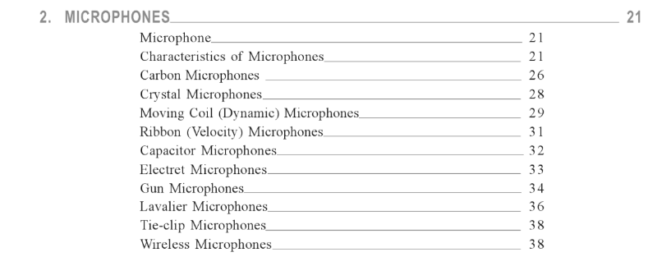

**LAVALIER MICROPHONE:**

For some applications portability is an essential necessity for an amplifiers, firearm receivers has a few focal points over those for all time mounted on a remain as they can be utilized in the hand and bore to the furthest reaches of the associating link length.

• As these can be fitted to a remain with fast discharge clips,they have a flexibility to which no uncertainty is because of the prominence of this sort of instrument.

A disservice is that one hand of the client is constantly involved and held up in an unnatural position this can force a genuine confinement on speaker or "Teachers" who may wish to show focuses with models or exhibits,use a chalkboard or simply be allowed to utilize signals.

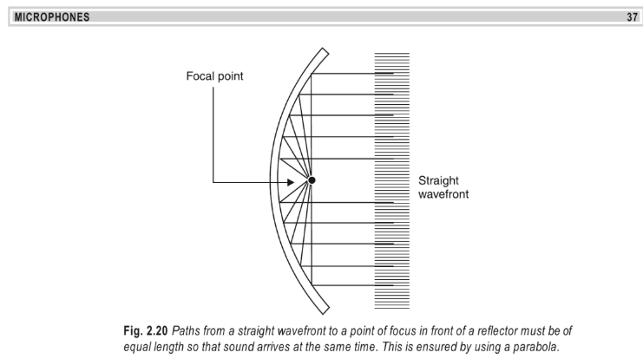

One answer to these problems is the “**lavalie**

|  |  |
| --- | --- |
| FM TRANSMITTER | **2019** |

**r microphone**”.

Which is a little transducer suspended on the cheat by methods for a line around the neck.

Any sort of instrument can be utilized for the reason by organizing appropriate fittings to take the string.

There are issues engaged with utilizing an amplifier in this way,one of these is the reverberation of the human chest depression which underlines frequencies around 700HZ and an ascent from 3KHZ and 10KHZ and give a muted generation.

So as to defeat these impacts exceptional receivers have been created for lavalier use .these have a dunk in their reaction around 700HZ and an ascent of 3KHZ upward,these qualities balance the inadequacies and result in a pretty much level generally speaking reaction. The recurrence bend in free air and that when utilized as a lavalier is appeared beneath chart.

In the chart in this regard an electrical receiver would be perfect for this application as the recurrence normal for the greater part of these instruments is that of rising treble and falling bass reaction.

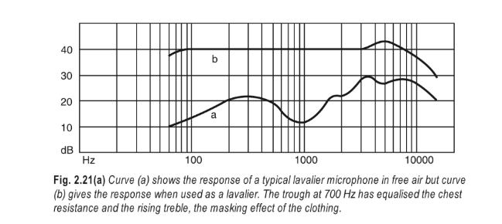

|  |  |
| --- | --- |
| FM TRANSMITTER | **2019** |

October 30, 2019

October 30, 2019

October 30, 2019

October 30, 2019

**CHAPTER 03**

**PROPOSED METHODOLOGY**

**BLOCK DIAGRAMS OF FM TRANSMITTER:**

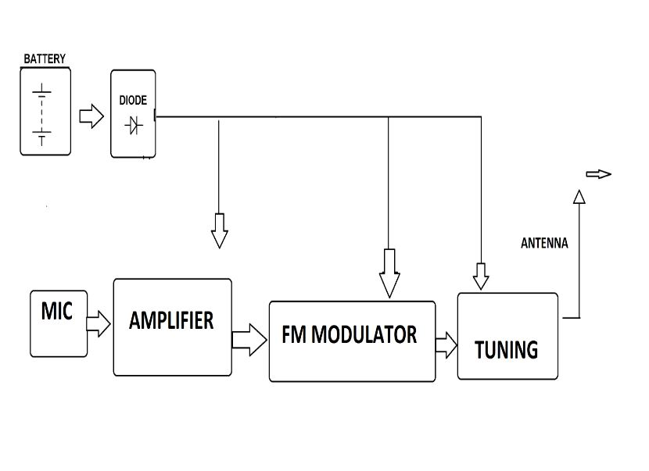

October 30, 2019

|  |  |
| --- | --- |
| FM TRANSMITTER | **2019** |

**CIRCUIT DIAGRAM USED:**

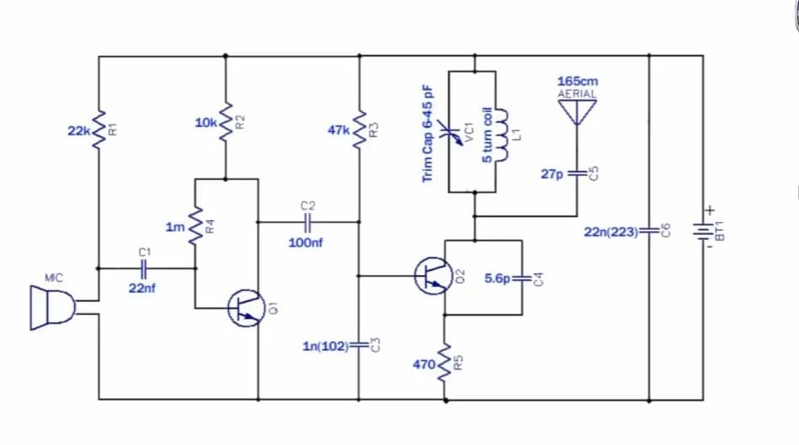

October 30, 2019

**The graph shows the circuit which we have used to make this task "FM TRANSMITTER (LAVALIER MICROPHONE)".**

**Which comprises of various segments, for example, mics,resistors,capacitors,transistors,Antenna,inductor coil(0.1uH),battery , e.t.c…**

FM TRANSMITTER CIRCUIT PRINCIPLE: The FM transmission is done through the procedure of sound preamplification, balance and transmission. Here, we adjusted a similar equation by first intensifying the sound signal, producing a transporter sign utilizing an oscillator, at that point balancing the bearer signal with the intensified sound sign. The intensification is performed utilizing a gamplifier, while the adjustment and the age of the bearer sign are performed utilizing a variable recurrence oscillator circuit. The recurrence is set anyplace in the FM recurrence extend 88 MHz to 108 MHz. The intensity of the oscillator FM sign is enhanced utilizing a power intensifier to deliver a low impedance yield adjusted to the reception apparatus.

|  |  |
| --- | --- |
| FM TRANSMITTER | **2019** |

**Theory behind the FM transmitter circuit:**

The sound sign from the receiver is a low sign, of the request for production line volts. This incredibly low voltage should initially be intensified. A typical producer setup of a bipolar transistor, one-sided to work in the class A district, creates an enhanced transformed sign.

Another significant part of this circuit is the Colpitt oscillator circuit. It is a LC oscillator where the vitality moves to and fro between the inductor and the capacitor by shaping motions. It is for the most part utilized for RF applications.

At the point when this oscillator gets an info voltage, the yield sign is a blend of the information signal and the swaying yield signal, delivering a balanced sign. As such, the recurrence of the circuit created by the oscillator shifts with the use of an info signal, delivering a regulated recurrence signal.

**FM transmitter circuit design:**

We structure here a solitary stage producer speaker as a preamp.

1) Vcc determination: Here we have chosen the NPN bipolar intersection transistor, QN222. As the VCEO for this transistor is around 40V, we pick an a lot littler Vcc, around 9V.

2) Selecting the heap resistor, R4: To ascertain the heap resistor esteem, the inert authority current should initially be determined. The gatherer voltage ought to be around half Vcc. This gives the estimation of the heap opposition, R4 as: Vc/Iq

3) Selection of the resistors of the voltage divider R2 and R3: To compute the estimation of the protections of the voltage divider, we should ascertain the predisposition current and the voltage over the resistors. The inclination current methodologies multiple times the base current. Presently, the base current, Ib is equivalent to the gatherer current separated by the present addition, hfe. This gives the estimation of Ib.

In this manner, R2 = Vb/Ibias

R3 = (Vcc-Vb/Ibias)

4) Selection of transmitter obstruction R5: Ve/Ie gives the estimation of R5, where Ie is the current of the transmitter and is around equivalent to the current of the authority. This gives R5 = (Ve/Ie). It is utilized to sidestep the current of the transmitter.Audio Preamp Design:

5) Selection of coupling capacitor C1: this capacitor is utilized here to balance the present coursing through the transistor. A high worth demonstrates a low recurrence (bass), while a lower worth builds the treble (higher recurrence).

|  |  |
| --- | --- |
| FM TRANSMITTER | **2019** |

6) Selection of the opposition of the receiver R1: the motivation behind this obstruction is to restrict the present going through the amplifier, which must be not exactly the greatest current that a mouthpiece can deal with.

7) Selection of the shunt capacitor, C4: Here, we select an electrolyte capacitor, which precludes the nonstop signal.

Since we need a low power yield, we like to utilize a Class A power speaker with a LC tank circuit at the yield. The estimations of the segments of the tank circuit are equivalent to in the oscillator circuit. Here, we select the predisposition resistor the coupling capacitor.

# Antenna determination:

Since the range is about 500m, we can set up a radio wire utilizing a recieving wire reception apparatus or a link of around 165 cm, which is around 1/4 of the length of the recieving wire. transmission wave.

**FM transmitter circuit operation:**

The above circuit graph shows the FM transmitter circuit and the electrical and electronic parts required for this circuit are the power supply, the resistor, the capacitor, the trimmer, the inductor, the amplifier, the transmitter and the transmitter. 'radio wire.

Think about the amplifier to comprehend the sound sign and inside the mouthpiece is a capacitive sensor. It produces as per the vibration during the difference in climatic weight and the AC signal.

The development of the wavering vessel circuit can be performed by means of the qn222 transistor utilizing the inductance and the variable capacitor. The transistor utilized in this circuit is a NPN transistor utilized for universally useful intensification. In the event that the present goes through the inductor L1 and the variable capacitor, the tank circuit will sway at the thunderous bearer recurrence of the FM regulation. The negative response will be capacitor C2 to the swaying tank circuit.

To produce the radio recurrence bearer waves, the FM transmitter circuit requires an oscillator. The tank circuit is gotten from the LC circuit to store the vitality required for the motions.

The sound info signal from the mouthpiece is contribution to the base of the transistor, which tweaks the bearer recurrence of the LC tank circuit to the FM group. The variable capacitor is utilized to change the reverberation recurrence for fine alteration of the FM recurrence band. The adjusted reception apparatus sign is transmitted as radio waves in the FM recurrence band

what's more, the recieving wire is just a copper wire 20 cm long and 24 check. In this circuit, the length of the recieving wire is reception apparatus ought to be significant. Furthermore, here you can utilize the 165 cm long copper wire from the recieving wire.

October 30, 2019

|  |  |
| --- | --- |
| FM TRANSMITTER | **2019** |

**CHAPTER 04**

**PROJECT DESCRIPTION**

|  |  |  |  |
| --- | --- | --- | --- |
| S. No | Required Components | Remarks | Quantity |
| 1 | MIC |  | 1 |
| 2 | INDUCTOR COIL | 0.1uH( 5 turns ) | 1 |
| 3 | AERIAL ANTENNA | 165 CM | 1 |
| 4 | TRIM CAP | 6-45 pF | 1 |
| 5 | RESISTORS | Quarter watt | R1=22K ohm --------1  R2=10K ohm-------- 1  R3=47K ohm---------1  R4=1m ohm--------- 1  R5=470 ohm---------1 |
| 6 | CAPACITORS | Ceramic,electrolytic | C1=22 nF--------------1  C2=100 nF------------1  C3=0.1 Uf--------------1  C4=5.6 pF-------------1  C5=27pF---------------1  C6=22n(223)----------1 |
| 7 | TRANSISTOR | Qn222 NPN transistor | 2 |
| 8 | Power supply |  | 1 |

October 30, 2019

**MIC:**

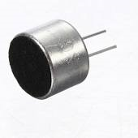

|  |  |
| --- | --- |
| FM TRANSMITTER | **2019** |

A lavallier or lapel mouthpiece (additionally called a magma, lapel amplifier, cut on receiver, body mouthpiece, neck receiver, neck amplifier or individual receiver) is a little mouthpiece utilized for TV, theater and TV.

Talking in broad daylight to permit hands free activity. Generally, little clasps are given to join to neckbands, ties or other attire. The link can be covered up by apparel and steered to a radio 0frequency transmitter put away in a pocket or joined to a belt, or coordinated straightforwardly to the blender or recording gadget.

These smaller than normal mouthpieces are regularly provided with a choice of slip-on frameworks of various lengths that give a smooth, high-recurrence beat when shaping a resounding depression.

A pinnacle of around 6 dB at 6-8 kHz is viewed as useful to make up for the loss of clearness when mounted on the chest, much the same as a pinnacle of a couple of decibels at 10-15 kHz when mounted on the speakers. hair on the temple. . This technique for expanding high frequencies doesn't intensify the exhibition regarding commotion, in contrast to an electronic evening out.

The lavalier amplifiers go back to 1932. A few models have been produced, incorporating those with condenser stomachs, strips, moving loops and carbon catches. The term alludes to any little mouthpiece prone to get trapped in the eyelet of a fold. The lapel receiver offers opportunity of development.

October 30, 2019

**INDUCTOR COIL:**

|  |  |
| --- | --- |
| FM TRANSMITTER | **2019** |

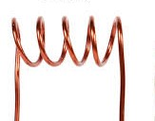

The inductor we utilized in this task is 0.1uH inductance comprises of 5 turns.

An inductor, likewise called a loop, stifle or reactor, is a two-terminal detached electrical part that stores vitality in an attractive field when the electric flow goes through it. An inductor by and large comprises of a protected wire twisted in a curl around a center.

At the point when the present streaming in an inductor changes, the time-shifting attractive field initiates an electromotive power (e.m.f.) (voltage) in the conductor, depicted by the Faraday enlistment law. As per Lenz's law, the actuated voltage has an extremity (course) that restricts the difference in current that made it. Subsequently, the inductors contradict any adjustment in the present moving through them.

An inductor is portrayed by its inductance, which is the connection between the voltage and the pace of progress of current. In the International System of Units (SI), the unit of inductance is Henry (H) named after the American researcher Joseph Henry of the nineteenth century. In the estimation of attractive circuits, this likens to weber/amps. The inductances have values that normally change from 1 μH (10-6 H) to 20 H. Numerous inductors have an attractive center of iron or ferrite inside the loop, which serves to expand the attractive field and thusly inductance With capacitors and resistors, inductances are one of the three components of the latent direct circuit that structure electronic circuits. Inductors are broadly utilized in AC electronic hardware, particularly radio gear. They are utilized to obstruct the substituting current while enabling the immediate current to pass; Inductors intended for this object are called joysticks. They are likewise utilized in electronic channels to separate sign of various frequencies and, in blend with capacitors for making tuned circuits, they are utilized to tune radio and TV inputs.

**AERIAL ANTENNA:**

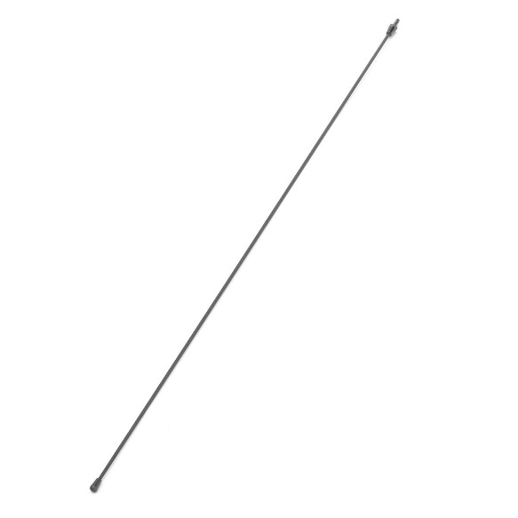

You have most likely seen that practically every one of the radios you see (like your cell phone, your vehicle radio, and so forth.) have a recieving wire. Reception apparatuses come in all shapes and sizes, contingent upon the recurrence the recieving wire is attempting to get. The reception apparatus can be a long and unbending link (like in AM/FM radio recieving wires in many autos) to something as peculiar as a satellite dish. Radio transmitters likewise utilize incredibly high reception apparatus towers to transmit their sign.

The thought behind a reception apparatus in a radio transmitter is to dispatch radio waves into space. In a recipient, the thought is to gather however much current as could reasonably be expected from the transmitter and supply it to the tuner. For satellites separated a few million kilometers separated, NASA utilizes tremendous satellite dishes up to 60 meters (200 feet) in measurement.

The size of an ideal radio recieving wire relies upon the recurrence of the sign that the reception apparatus is attempting to transmit or get. The purpose behind this relationship is identified with the speed of light and, subsequently, the separation went by the electrons. The speed of light is 300 000 km/s. On the following page, we will utilize this number to compute the size of a real radio wire.

Reception apparatus Modulation in improve signal quality drastically when utilizing a lot littler recieving wires. The analysts have shown the idea utilizing reception apparatuses 33% the size of a traditional radio wire for a given wavelength.

Radio wire plays a significant and key job in transmitting the sign and adjusting the sign to faraway places which is vey far separation .

|  |  |
| --- | --- |
| FM TRANSMITTER | **2019** |

October 30, 2019

**RESISTORS:**

|  |  |
| --- | --- |
| FM TRANSMITTER | **2019** |

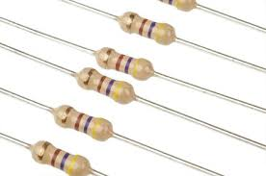

A resistor is a uninvolved two-part electrical segment that actualizes an electrical resistor as a circuit component. In electronic circuits, resistors are utilized to decrease current stream, alter sign levels, isolate voltages, predisposition dynamic components, and end transmission lines, among different employments. High control resistors that can disseminate numerous watts of electrical vitality as warmth can be utilized in engine controls, in control conveyance frameworks, or as test loads for generators. Fixed resistors have protections that change just marginally with temperature, term or working voltage. Variable resistors might be utilized to modify circuit components, (for example, a volume control or light dimmer), or as gadgets for recognizing heat, light, dampness, power, or concoction movement.

Resistors are regular components of electrical systems and electronic circuits and are universal in electronic hardware. Handy resistors as discrete parts might be made out of different mixes and frames. Resistors are additionally executed in coordinated circuits.

The electrical capacity of a resistor is determined by its opposition: basic business resistors are produced in a scope of in excess of nine sets of size. The ostensible obstruction worth is inside the assembling resistance determined in the segment.

There are two associations which electrical parts are associated inside the circuit-arrangement and parallel.

they comprises of various shading codes: BBROYGBPGW

October 30, 2019

**capacitors:**

|  |  |
| --- | --- |
| FM TRANSMITTER | **2019** |

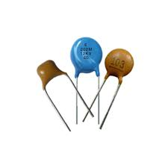

A capacitor is a gadget that stores electrical vitality in an electric field. It is a latent electronic part with two terminals.

The impact of a capacitor is called capacitance. Despite the fact that there is some capacitance between two close by electrical channels in a circuit, a capacitor is a part intended to add capacitance to a circuit. The capacitor was initially known as a capacitor or capacitor. The first name is still generally utilized in numerous dialects, yet not smoothly in English.

The physical structure and development of the down to earth capacitors differ generally and numerous kinds of capacitors are regularly utilized. Most capacitors contain at any rate two electrical transmitters regularly as metal plates or surfaces isolated by a dielectric medium. A conveyor might be a sheet, a slim film, a sintered metal dab, or an electrolyte. The non-conductive dielectric acts to build the capacitance of the capacitor.

Normally utilized materials, for example, dielectrics incorporate glass, earthenware, plastic movies, paper, mica, air and oxide layers. Capacitors are generally utilized as parts of electrical circuits in numerous basic electrical gadgets. In contrast to a resistor, a perfect capacitor doesn't disseminate vitality.

At the point when an electrical potential is applied, a voltage over a capacitor, for instance when a capacitor is associated over a battery, an electric field creates over the dielectric, causing a net charge to amass on a base and a net negative charge. get on the other plate. No flow really courses through the dielectric. Nonetheless, there is a charge move through the source circuit. In the event that the condition is kept up adequately, the current through the source circuit stops. On the off chance that a variable voltage is applied after some time through the capacitor drives, the source encounters a DC current as a result of the charge and release cycles of the capacitor.

|  |  |
| --- | --- |
| FM TRANSMITTER | **2019** |

**TRANSISTOR:**

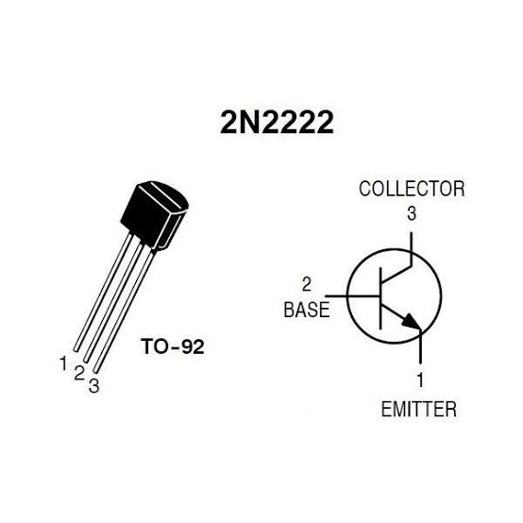A transistor is a device with three terminals.BASE,EMMITER,COLLECTOR

Base: is responsible for activating the transistor.

Collector: This is the positive thread.

Transmitter: it's the negative cable.

The essential thought behind a transistor is that it enables you to control the progression of current in a channel by shifting the force of an a lot littler current coursing during a time channel.

A transistor is a semiconductor gadget used to enhance or alter electronic signals and electrical vitality. It is made out of semiconductor material, as a rule with in any event three terminals for association with an outer circuit.A voltage or current applied to a couple of transistor terminals controls the current through another pair of terminals. Since the controlled power (yield) might be more noteworthy than the control (input), a transistor may enhance a sign. Today, a few transistors are separately bundled, yet a lot more are incorporated in coordinated circuits.

Most transistors are very unadulterated silicon and germanium, however other semiconductor materials can likewise be utilized. A transistor can have just one kind of burden transporter, in a field impact transistor, or two sorts of burden bearer in bipolar intersection transistor gadgets. Contrasted with the vacuum tube, the transistors are commonly littler and require less vitality to work. Some vacuum cylinders have points of interest over transistors at high working frequencies or at high working

|  |  |
| --- | --- |
| FM TRANSMITTER | **2019** |

**TRIM CAP,POWER SUPPLY:**

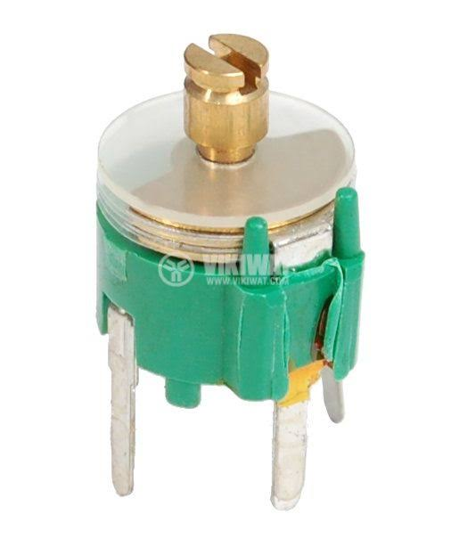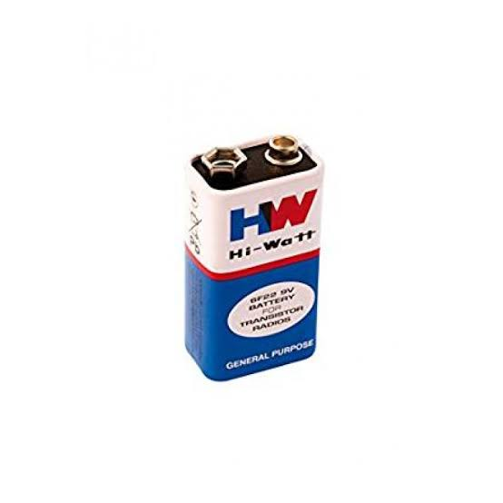

TRIM CAP:

• To enable the oscillator to tune the whole FM go

• The transmission band has two alteration plugs on the circuit.

• The yellow alteration spread is utilized to tune the transmittera clear piece of the tape and the clear can be utilized to

• Set the transmitter to the ideal recurrence.

POWER SUPPLY:

RF vitality can spare vitality if the stock voltage is adjusted progressively. The power supply requires a little yield ability to get a quick voltage regulation with a high productivity and a little size.

These necessities become a test if a generally excellent guideline is additionally required if there should arise an occurrence of forceful changes in the charging current. In this archive, a nitty gritty examination of the channel plan and decrease converter control prompts a low proficiency and a little structure that meets the necessities of dynamic guideline, including forceful burden current varieties., with a low yield limit.

The intertwining of currency converters turns out to be the enabling solution. A prototype has been built and the measurements are in agreement with the theoretical results.

October 30, 2019

**CHAPTER 05**

|  |  |
| --- | --- |
| FM TRANSMITTER | **2019** |

**RESULT AND DISCUSSION**

**DISCUSSION:**

**FM transmitter application:**

• FM transmitters are utilized at home as sound frameworks in foyers to fill the sound with the sound source.

• They are additionally utilized in autos and wellness focuses.

• Correctional offices have been utilized in FM transmitters to decrease jail commotion in common regions.

**Advantages of FM transmitters:**

• FM transmitters are anything but difficult to utilize and their cost is low.

• The effectiveness of the transmitter is high.

• It has a wide working reach

• This transmitter will dismiss the commotion sign of a variety of plentifulness.

# Disadvantages of the FM transmitter:

• A bigger, bigger channel is required on the FM transmitter.

• The FM transmitter and beneficiary will in general be progressively mind boggling.

• Due to some obstruction, the nature of the got sign is poor.

**RESULT:**

The undertaking to transmit voice/signal through fm transmitter utilizing lavalier amplifier has been effectively executed and positive outcomes are gotten.

We can hear the voice of the speaker through fm at the specific scope of recurrence and separation.

October 30, 2019

|  |  |
| --- | --- |
| FM TRANSMITTER | **2019** |

**CHAPTER 06**

**CONCLUSION AND FUTURE SCOPE**

October 30, 2019

**Conclusion:**

The undertaking to transmit voice/signal through fm transmitter utilizing lavalier receiver has been effectively actualized and great outcomes are acquired, We can hear the voice of the speaker through fm at the specific scope of recurrence and separation.

This is economically feasible item and its application is far reaching nowadays with nearly of all home sound frameworks ,fm radio ,telecom over higher scope of separation and with a recurrence ,since transmission is utilized here, each undertaking can be intended to be performed at various frequencies ,every particular to a specific range. Because of which a few uses can be performed on a solitary fm transmitter, as if there should be an occurrence of vehicles , wellness focuses .this item as of now has an incredible breadth and vision now and modernly, as a piece of a situation where man confines his movement and plays out his everyday exercises on a FM transmitter utilizing lavalier mouthpiece.

• The Lavaliers mouthpieces are exceptionally less expensive when all is said in done. Obviously, you can locate a progressively costly magma amplifier in the $ 2,000 zone

• The Lavaliers are anything but difficult to cover up.

• The Lavaliers mouthpieces realizes how to shroud the consistent foundation commotion.

• Lavaliers can interface with remote ability.

• Lavaliers can be utilized to record gatherings covertly.

o Improved signal-to-commotion proportion (about 25dB) The man made some obstruction.

o Less geographic impedance between neighboring stations.

o Less emanated control.

o Well-characterized administration regions for given transmitter control.

Along these lines, we presume that this task is genuinely appropriate for electrical and correspondence designing learning understudies, especially understudies who are devoted to FM transmission and gathering in their subject of gadgets and interchanges hypothesis. By understanding this application and task hypothesis more,

|  |  |
| --- | --- |
| FM TRANSMITTER | **2019** |

**FUTURE SCOPE:**

Fm transmitter as of now has procured an incredible breadth now and modernly also,This task covers the plan of the FM transmitter for quality sound transmission and clarifies a portion of the cutting edge inclines in FM signal age, featuring their points of view.

It likewise covers the advantages of these advancements over conventional radio transmission and features a few of the unmistakable highlights that these innovations have.

The job that radio plays in the general public is a significant issue to consider in dialogs about which innovation can best convey radio in the future.the certainty that radio has a significant job in the public eye can be unmistakably found in the quantity of audience members as indicated by a review detailed In [3,pp,40-49].

• Noise decrease

• Improvement of the affectability of radio wire

• Development of SNR.

The "Remote TV Audio Transmitter" is as yet a youthful innovation. Thus, numerous buyers are ignorant of the advantages that this kind of collaboration can bring to regular daily existence. In this undertaking, we notice some future frameworks dependent on "remote TV sound transmitter" that resembles the smoothness of this procedure contrasted with others.

The principle objective of this undertaking is to get a sound signal from the TV and hear it out from a separation. These days, everybody needs home theater, which is a home-fabricated theater, intended to emulate the presentation and feel of business theater, all the more normally known as home theater.

What's more, this sound framework or home venue is over the top expensive, however this venture can truly assist you with experiencing a showy presentation at no expense. The expense of remote TP transmission is essentially diminished.

The most significant thing is that it tends to be utilized in TV applications, yet in addition in PCs. workstations, versatile and convenient music frameworks. This is viable when the sound volume should be decreased. Moreover, it tends to be utilized as an option to Bluetooth innovation since it devours less power.

The report is presented in partial fulfilment of the requirements for the award of the degree masters of engineering in electronics and communication engineering.

This report is an orginal work carried out by our group under the supervision of guide it has not been presented to any other higher situation. It has been fully acknowledged and referenced

October 30, 2019

|  |  |
| --- | --- |
| FM TRANSMITTER | **2019** |

**REFERENCES**

[1] Nelson D.Tineo ,”FM Transmitter”, California State University, Nelson D.Tineo,Year of Publication-2014

[2] Tips on using FM Transmitters,” Guides at Overstock.com”, Overstock.com, 14 october 2014.

[3] serway,Raymond,Faughn,jerry,vuille,” college physics,8th Ed”, cegage learning.p.714, ISBN 0495386936 ,NOV-2014

[4] S P BALI,Former Faculty member,Military college of electronics and mechanical engineering,

[5]herald hass,german physicist

October 30, 2019

October 30, 2019

|  |  |
| --- | --- |
| FM TRANSMITTER | **2019** |

**APPENDIX**

October 30, 2019